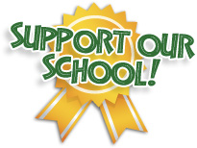  We need your help!  It’s easy to help CME – Read below!  Would you like to help CME raise money with little effort? We thought so and we appreciate you! Just clip your Box Tops, and Coke Rewards and turn them in. We will do the rest!  Also, do you have a Target RED card? If so, just link your card (via Target’s app or website, to CME) and a portion of your purchase goes to our school!  Do you shop on Amazon? If so, Amazon is giving back to schools. All you have to do is log into: smile.amazon.com and choose “Cape Coral Charter School Authority”. Each time you make a purchase, a portion goes to our schools!  POWER CME WITH POWERADE!  Nominate our school and we could receive up to $10K! Share your Power Through story by submitting a video or essay to: https://us.coca-cola.com/offers/ | Box Tops  Just clip and send in a baggie with your student!  Target RED Card  Link CME to your card via app or website!  Coke Rewards  Find rewards on coke products!  Amazon  Smile.amazon.com  Choose: “Cape Coral Charter School Authority”

