Get Your Boot Camp for
Veterans T-shirts!!!! 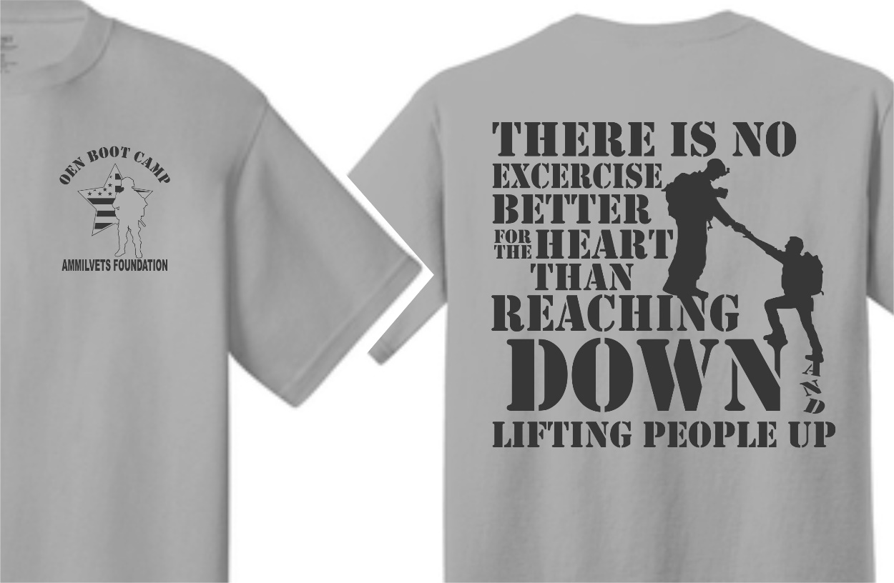
(Shirt Color is tan with green graphics on it)
All proceeds will benefit the American Military Veterans Foundation. Students may wear these shirts to school on Fridays and to our Boot Camp for Veteran’s event on Friday, February 21st. Cost is $12 per shirt. You can pay in exact cash or by check made payable to CME PTO.
______________________________________________________________________
Student Name: ____________________________
Teacher’s Name____________________________
Total # of Shirts ________
Size (circle): Child S, M, L, XL
Adult S, M, L, XL, 2XL
T-shirt orders are due Friday, February 7th to PTO.

